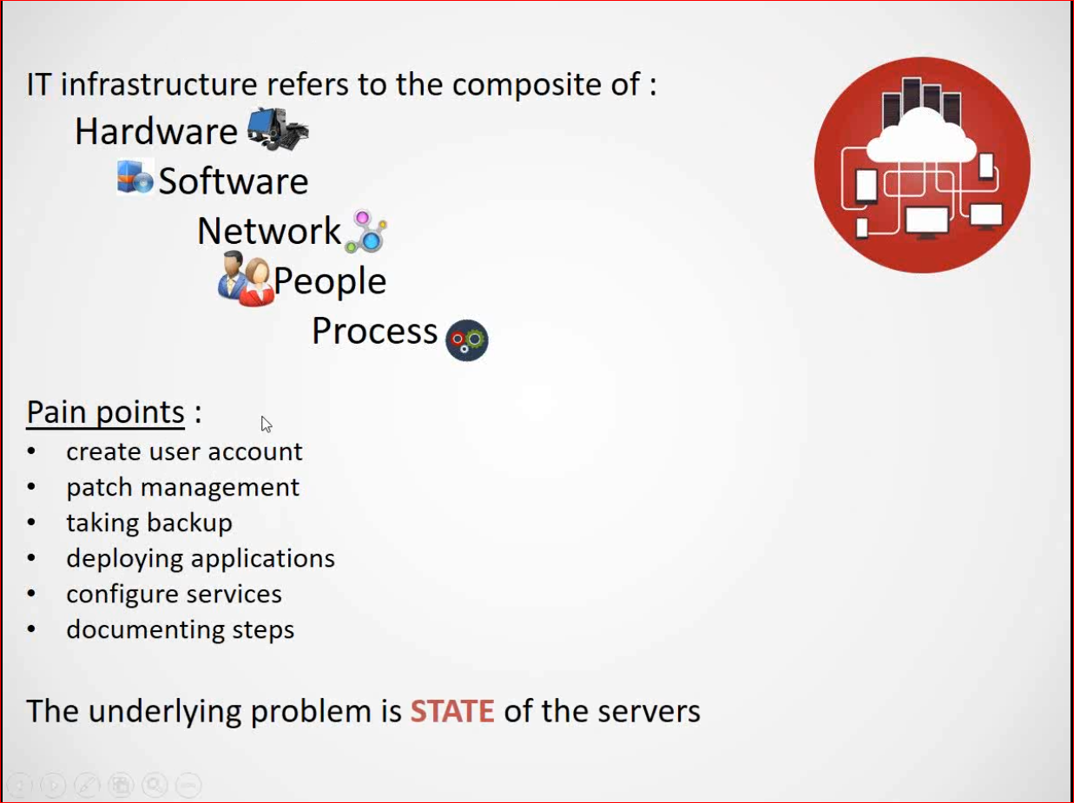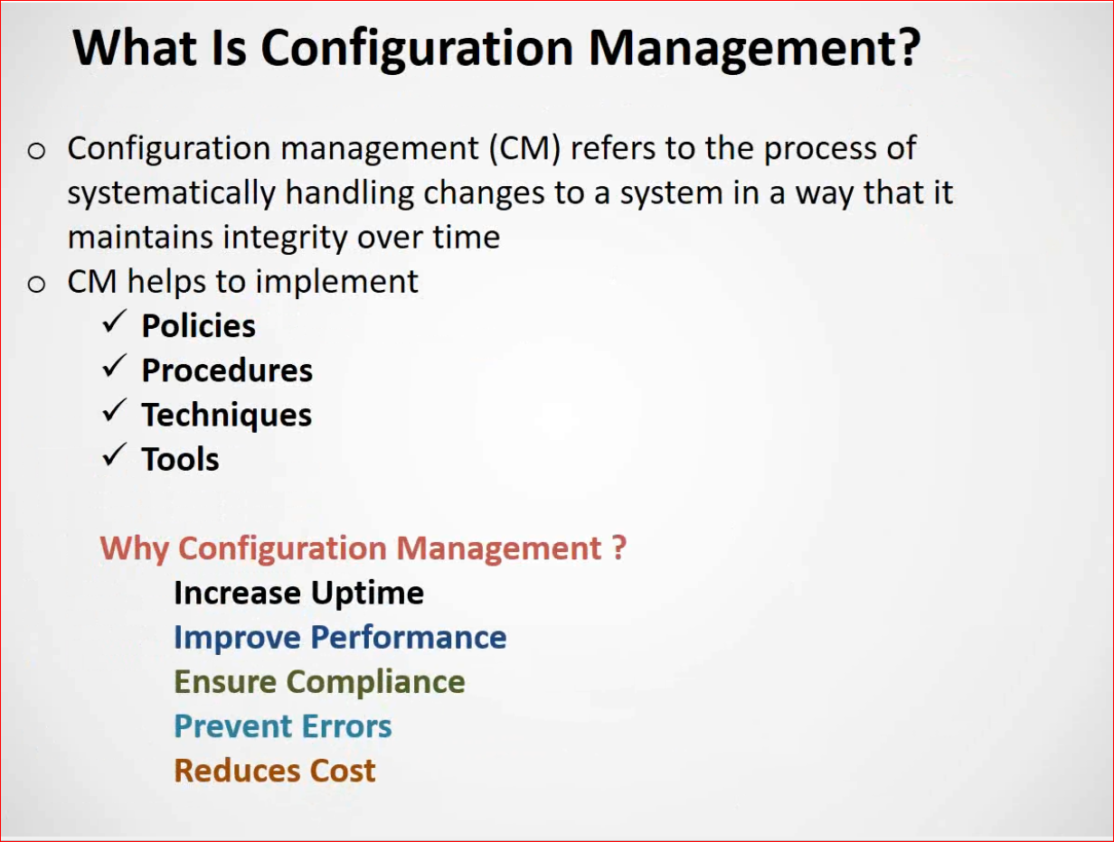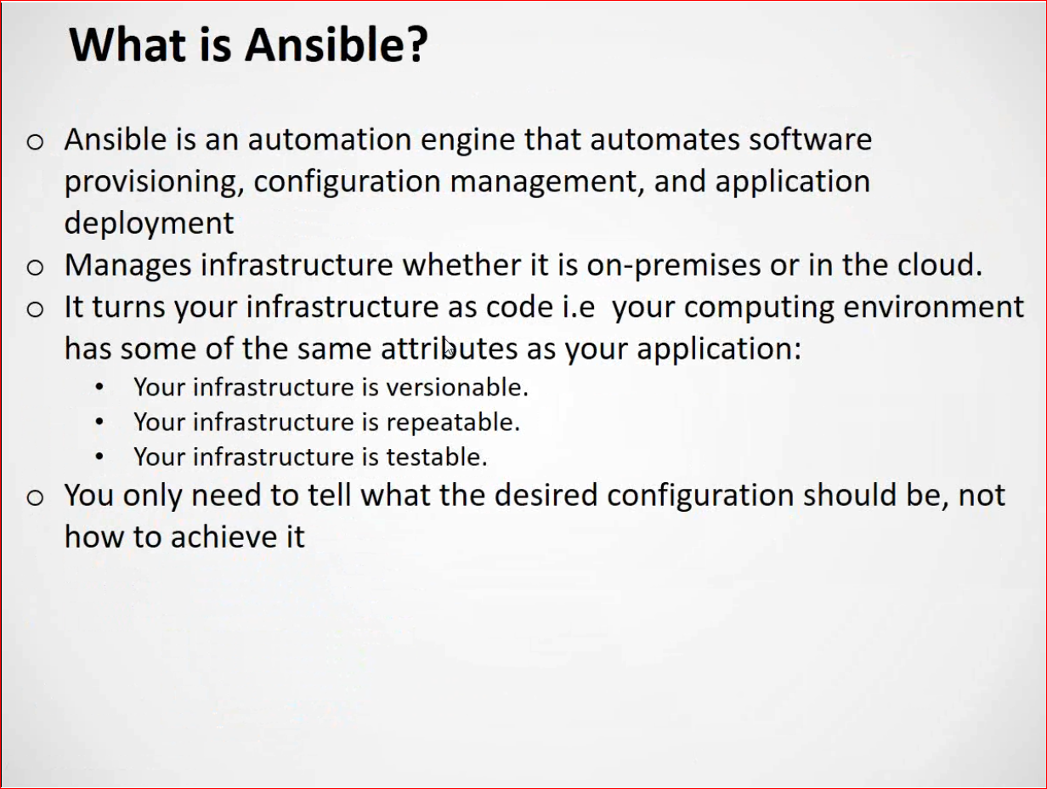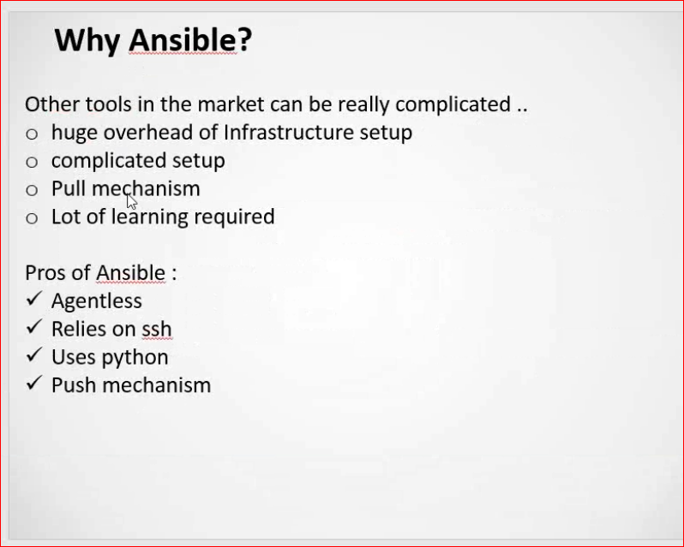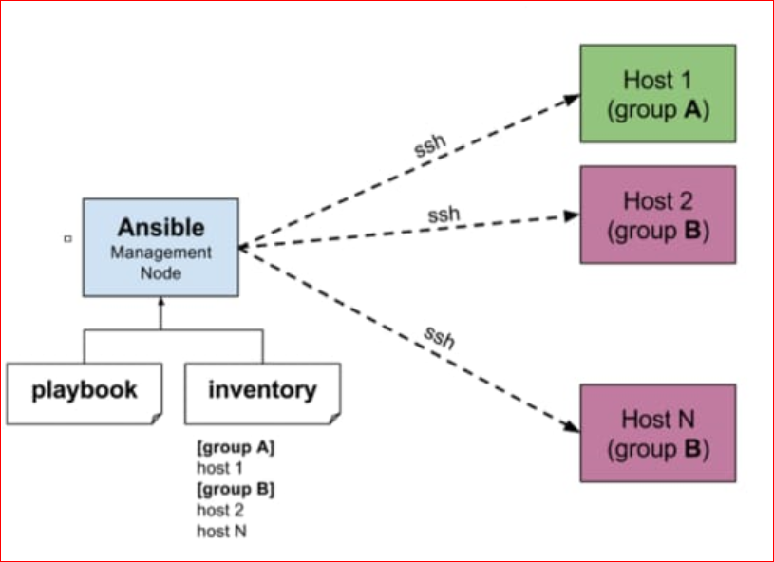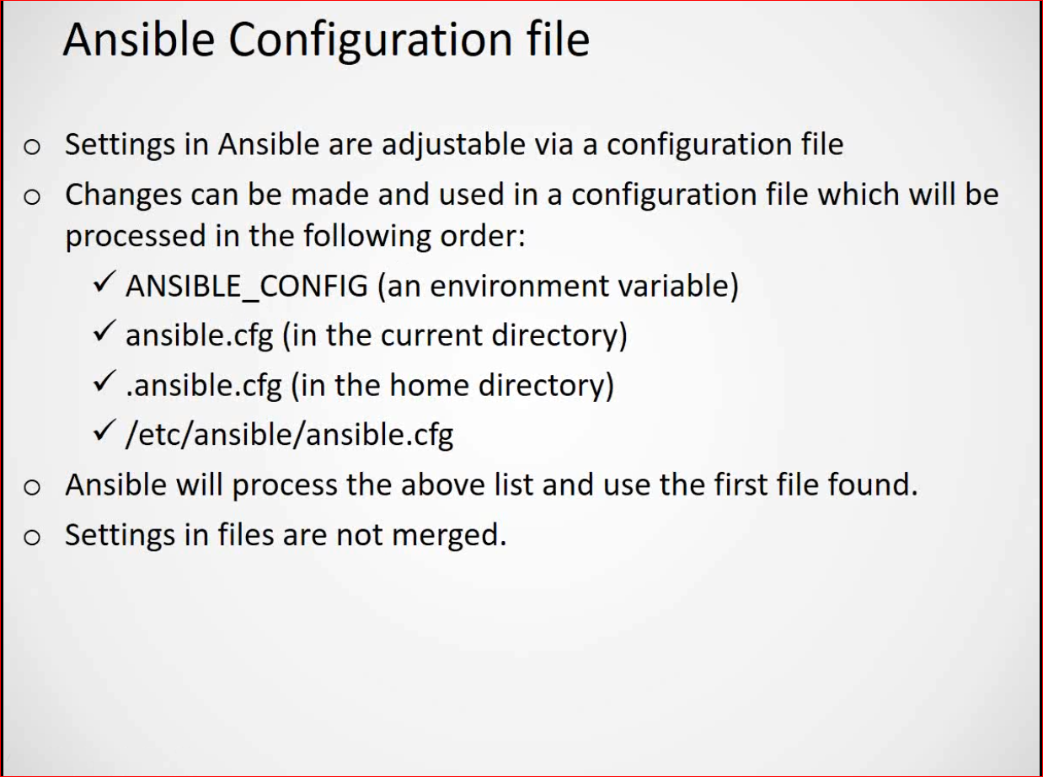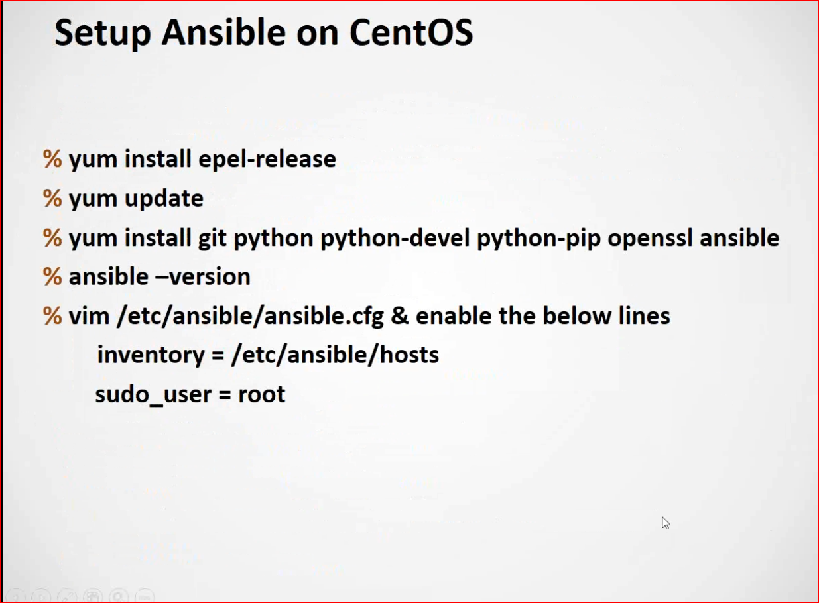

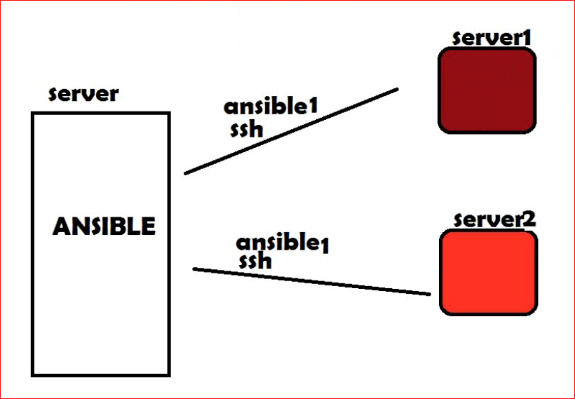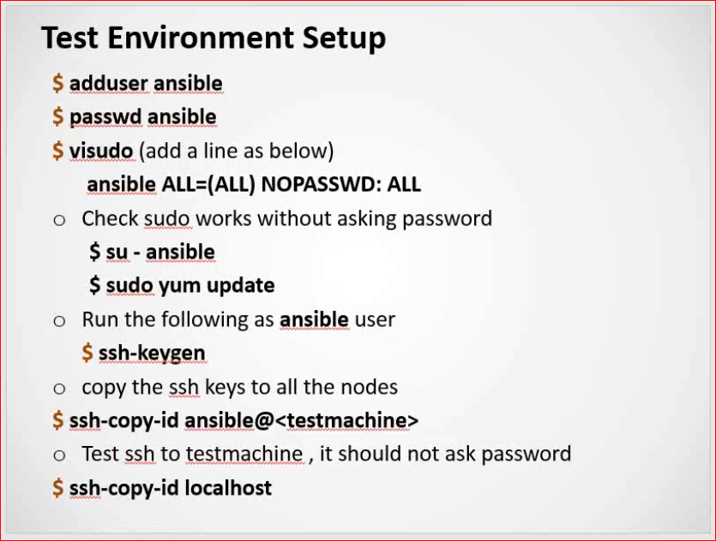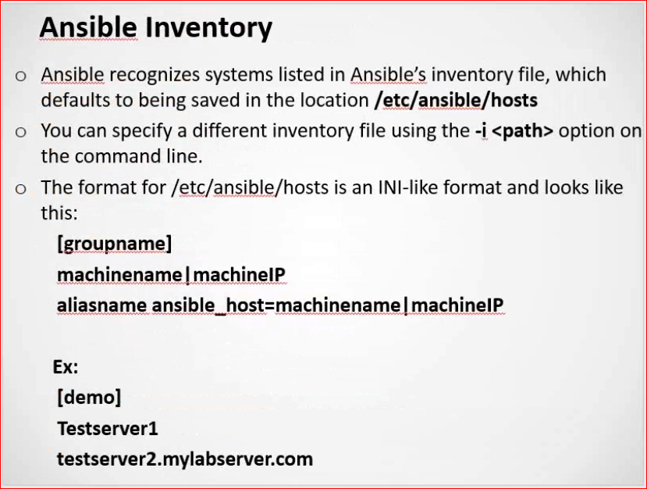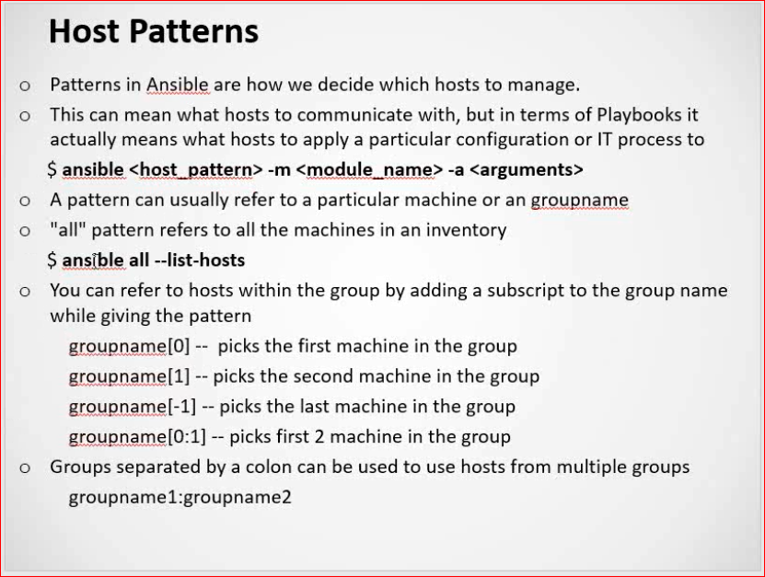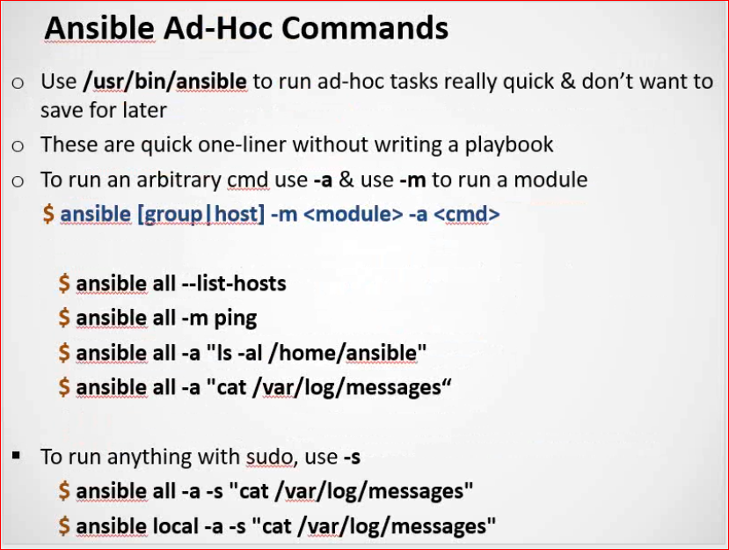

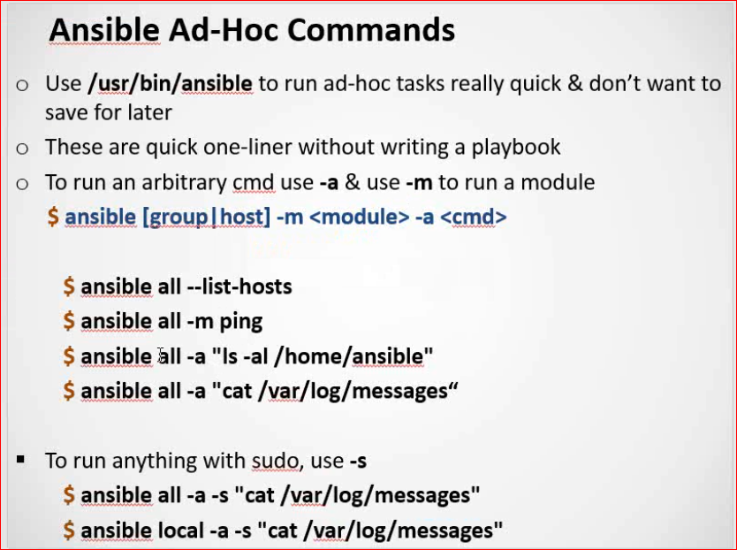

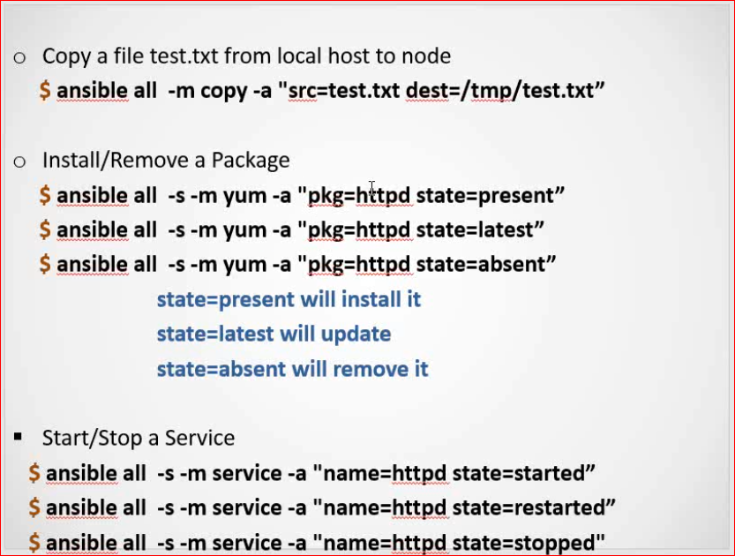

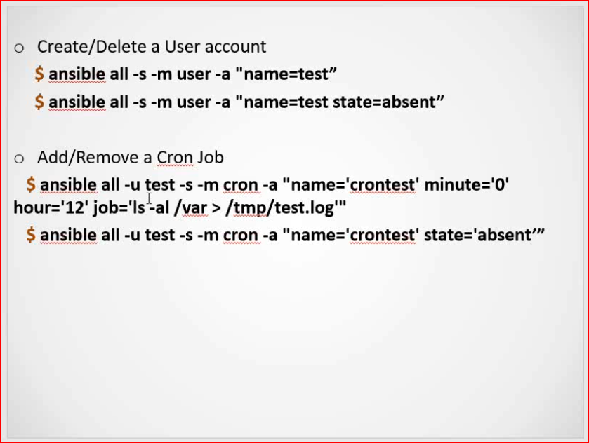

[root1@muthu ~]$ ansible demo -m shell -a "hostname;uptime;who -r;date"

192.168.124.144 | CHANGED | rc=0 >>

muthu

10:11:34 up 2:40, 4 users, load average: 0.00, 0.00, 0.00

run-level 3 2020-11-24 07:31

Tue Nov 24 10:11:34 IST 2020

192.168.124.145 | CHANGED | rc=0 >>

localhost.localdomain

22:28:21 up 1:45, 3 users, load average: 0.00, 0.01, 0.05

run-level 5 2020-12-04 20:43

Fri Dec 4 22:28:21 PST 2020

[root1@muthu ~]$ ansible demo -b -m user -a "name=sebsav"

192.168.124.145 | CHANGED => {

[root1@muthu ~]$ ansible demo -b -m user -a "name=sebsav state=absent"

192.168.124.144 | CHANGED => {

"ansible_facts": {

"discovered_interpreter_python": "/usr/bin/python"

},

"changed": true,

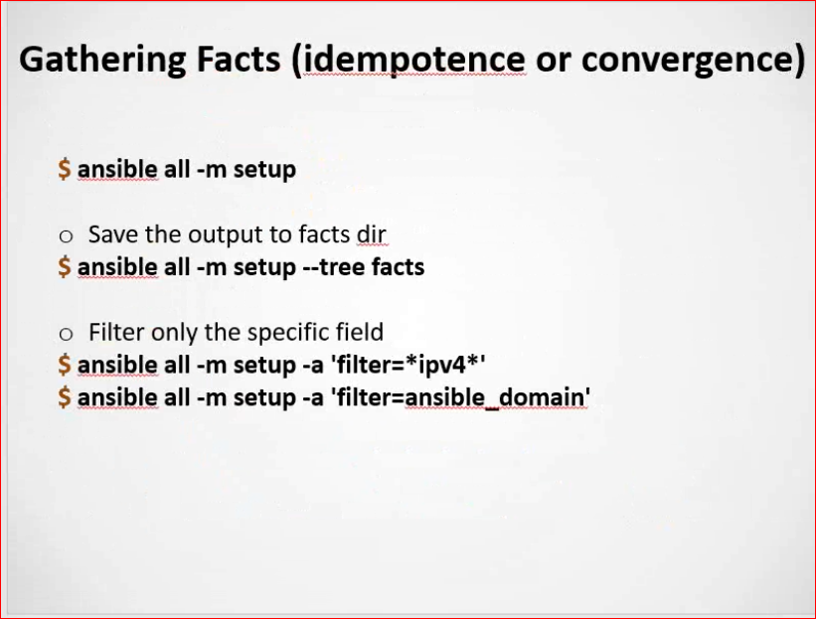

Real time Example for few module:

**Yum Module:**

$ ansible demo -b -m yum -a "pkg=httpd state=present"

$ ansible demo -b -m yum -a "pkg=httpd state=latest"

$ ansible demo -b -m yum -a "pkg=httpd state=absent"

**Service Module:**

$ ansible demo -m service -a "name=httpd state="started"

$ ansible demo -b -m service -a "name=httpd state=stopped"

$ ansible demo -b -m service -a "name=httpd state=restarted"

**user Module:**

$ ansible demo -m user -a "name=sebsav"

$ ansible demo -b -m user -a "name=sebsav state=absent"

**Cron Module:**

$ ansible demo -b -m cron -a "name='crontest' job='service httpd status'"

$ ansible demo -b -m cron -a "name='crontest' job='service httpd status' state=absent"

**Shell Module:**

$ ansible all -m shell -a "hostname;uname -a;free -m;df -Th"

**File Module:**

$ ansible demo -m file -a "name=/home/root1/sebsav state=absent"

**Copy Module:**

$ ansible demo -m copy -a "src=/home/root1/sebsav dest=/home/root1/"

**Few other command**

$ ansible demo --list-hosts

$ ansible 192.168.124.145 -m setup

$ ansible demo -m copy -a "src=/home/root1/sebsav dest=/home/root1/"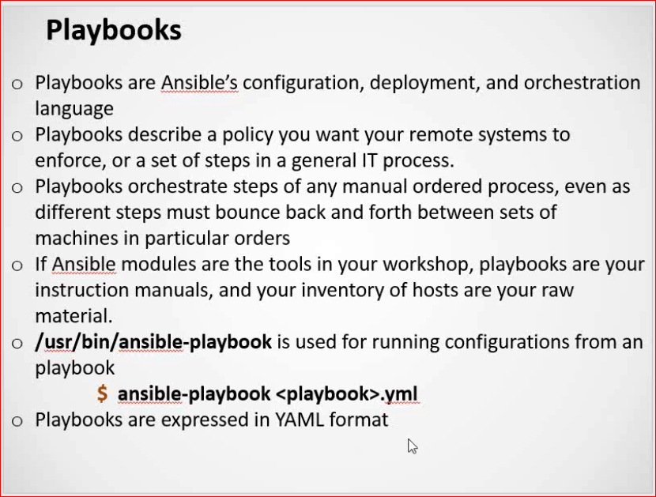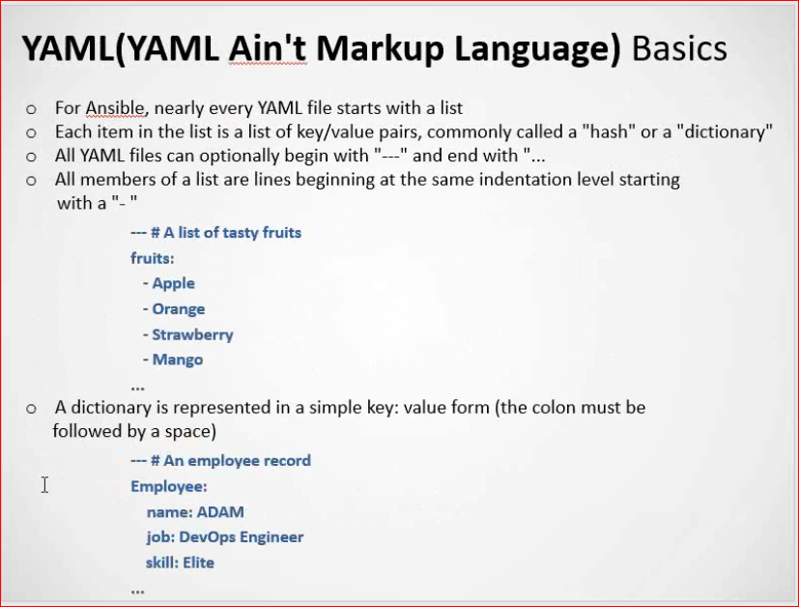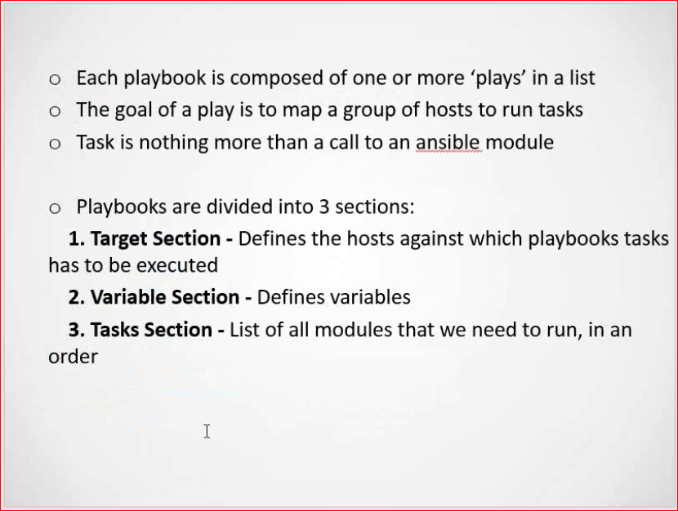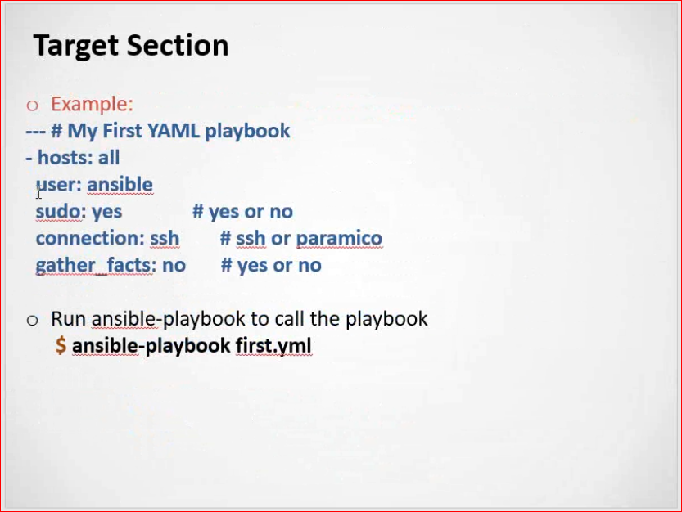

Ansible Sudo or Ansible become Introduction

Ansible Sudo or become is a method to run a particular task in a playbook with Special Privileges like root user or some other user.

In the earlier versions of ansible there is an option named as **sudo**which is deprecated now, Since ansible 2.0 there are two new options named as **become** and **become_user**

Let’s suppose you want to run a task on the remote server to install some packages using yum. It’s very obvious that you should become root user as Non-Root user cannot install packages, in this case, you can use ansible sudo. To be precise ansible **become** method

Now, Let’s discuss another requirement where you have to start a WebSphere application server instance on the remote machine which runs as wsadmin user. In this case, you might want to restart the instance as wsadmin only for which you can execute your ansible task with **become-user** method

Reference Link - [Ansible sudo - ansible become example | DevOps Junction (middlewareinventory.com)](https://www.middlewareinventory.com/blog/ansible-sudo-ansible-become-example/)

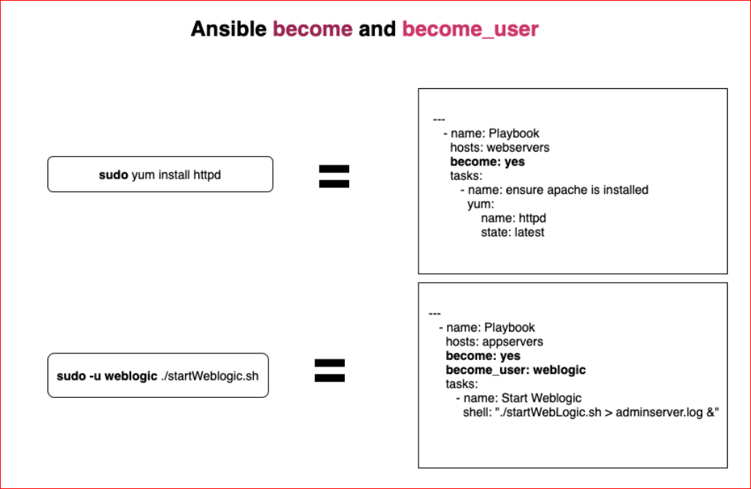

Sample Playbook code:

**[root1@muthu playbooks] $ cat felics.yml**

**--- # Second YAML Code**

**- hosts: demo**

**become: yes**

**user: root1**

**gather_facts: no**

**tasks:**

**- name: Installing FTP**

**yum:**

**name: vsftpd**

**state: present**

**- name: starting service**

**service:**

**name: vsftpd**

**state: started**

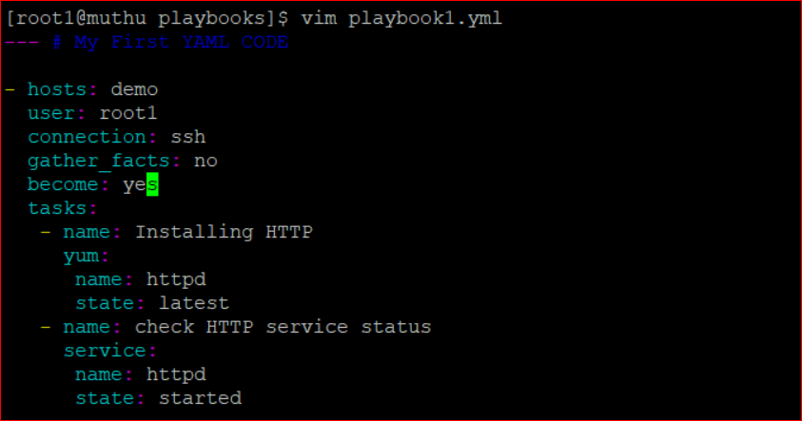

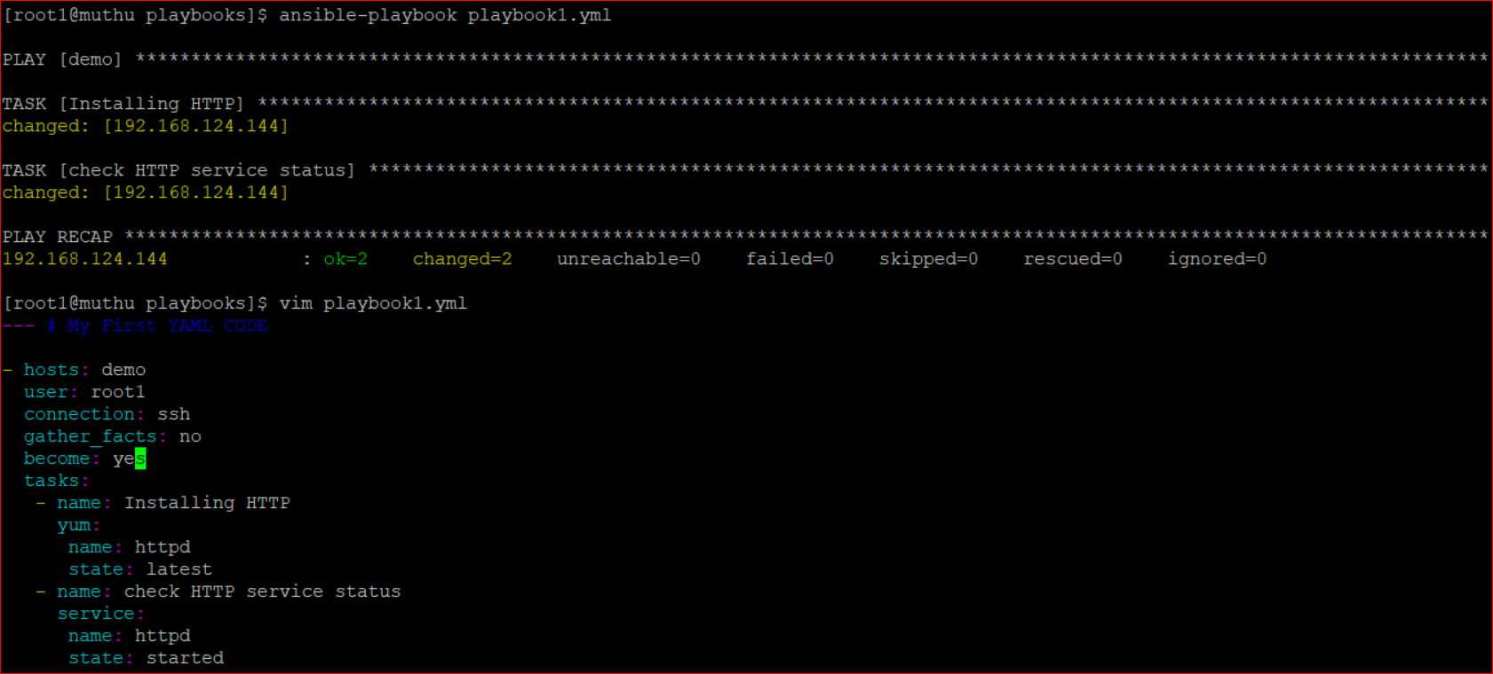

Example with variable section:

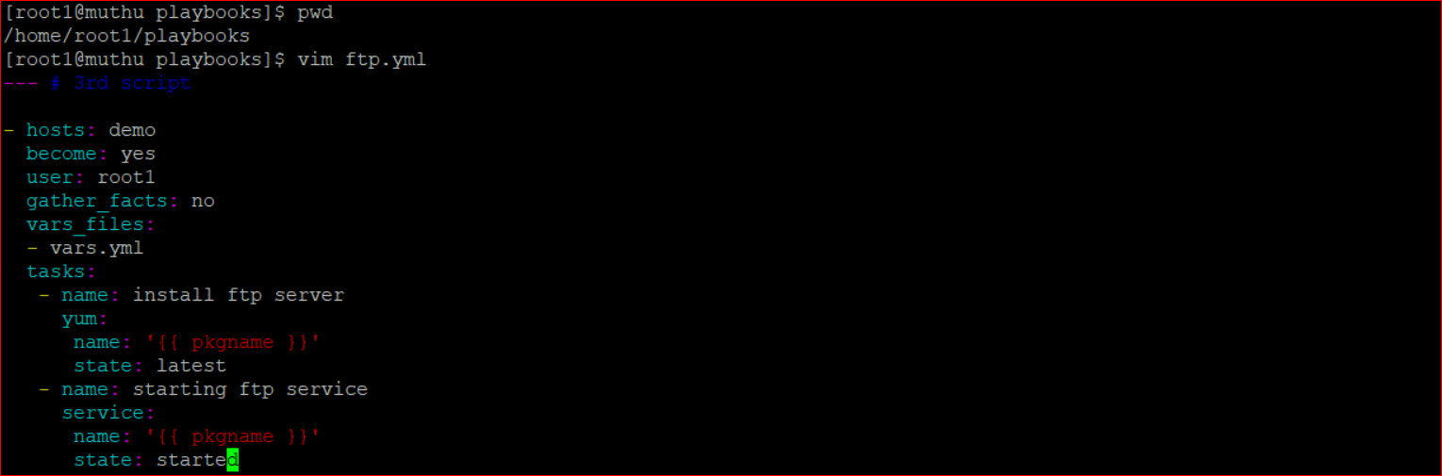



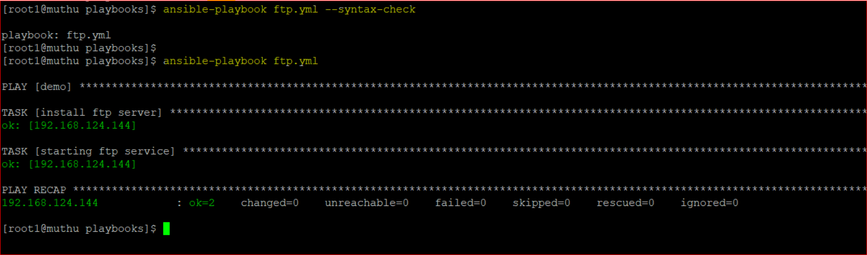

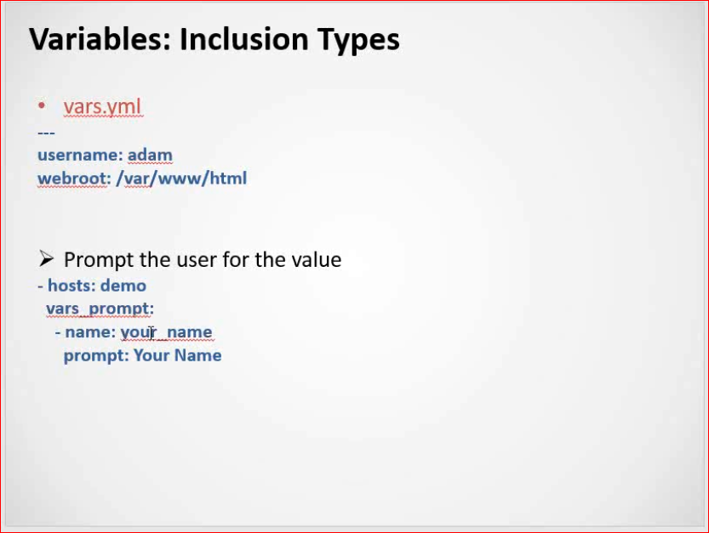

Example for prompt:

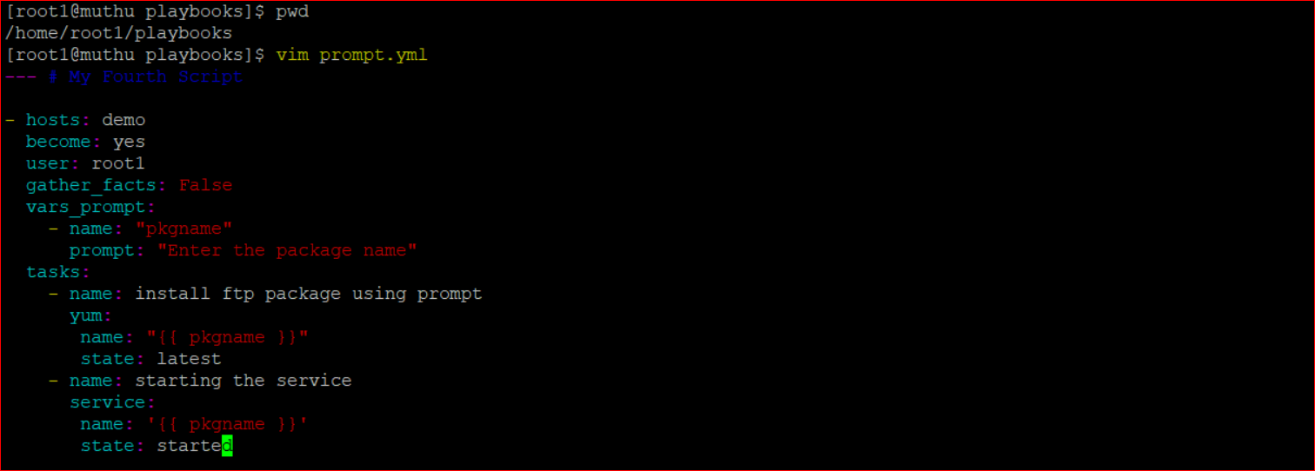

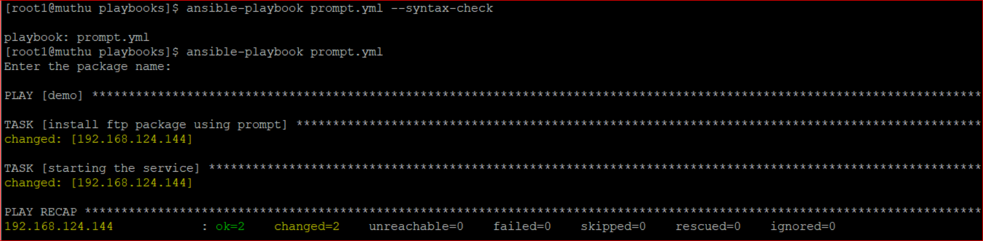

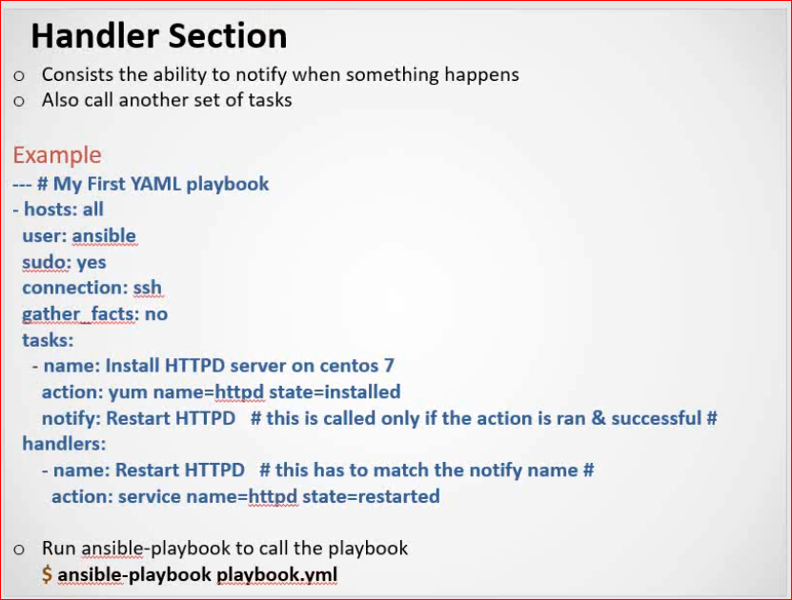

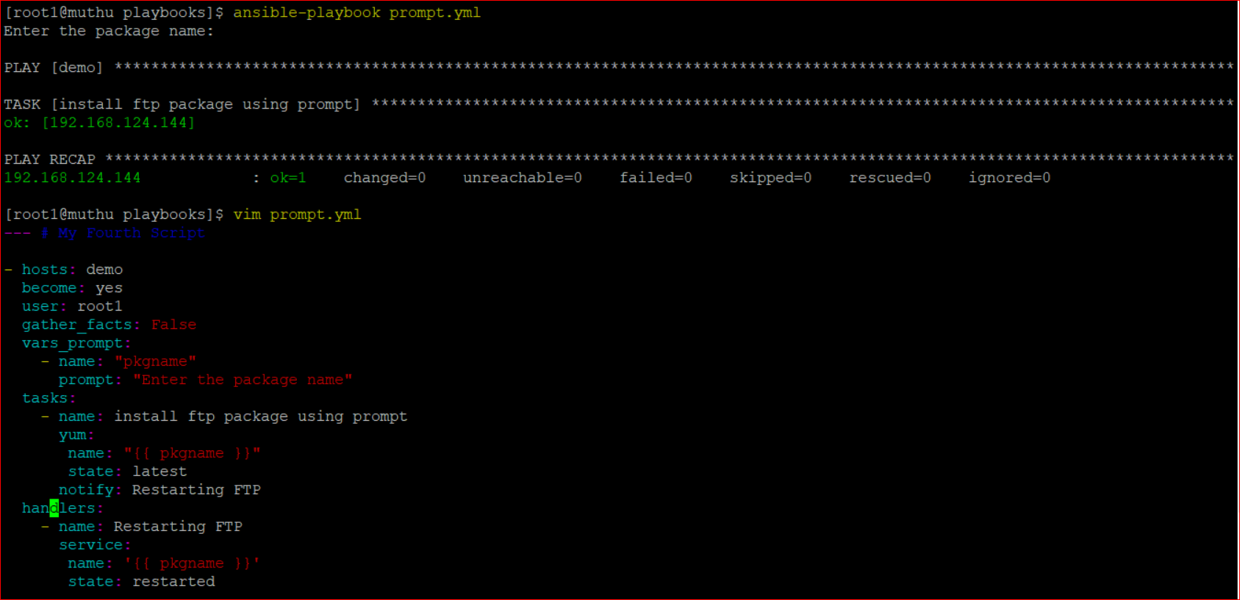

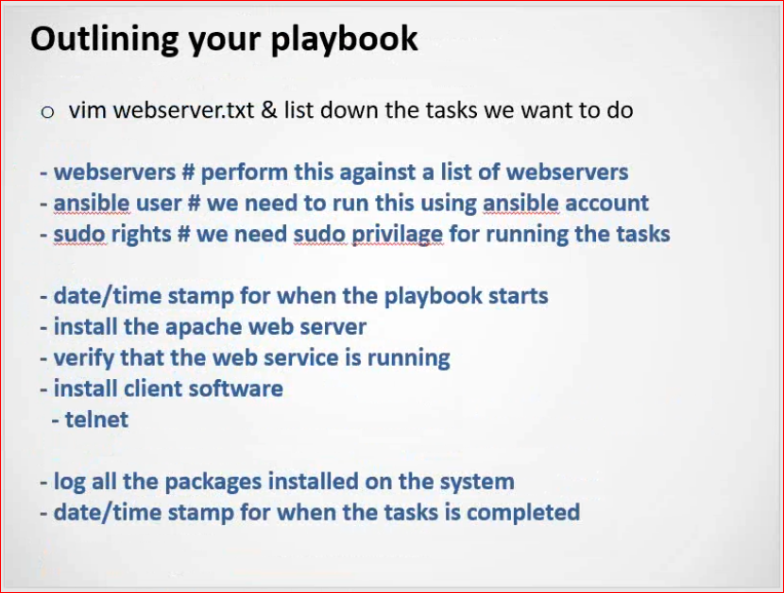

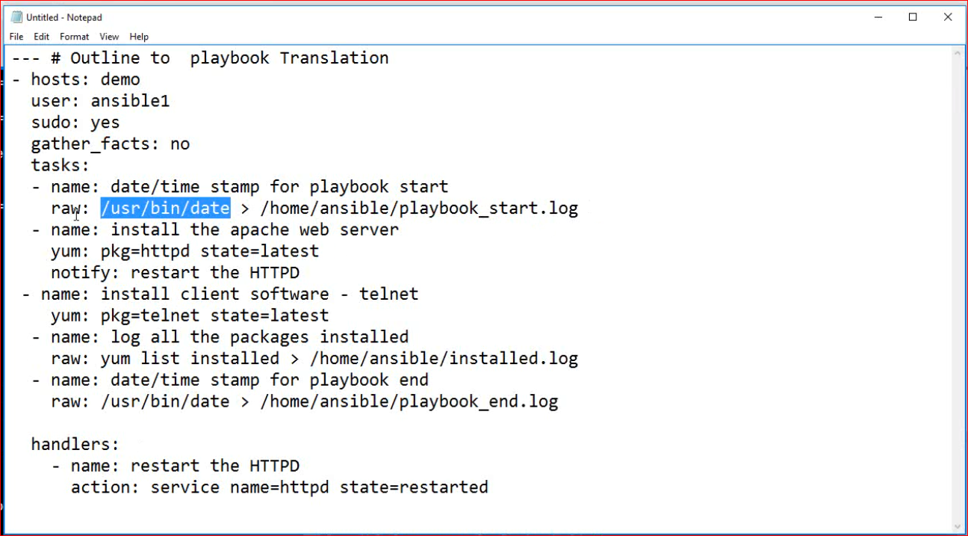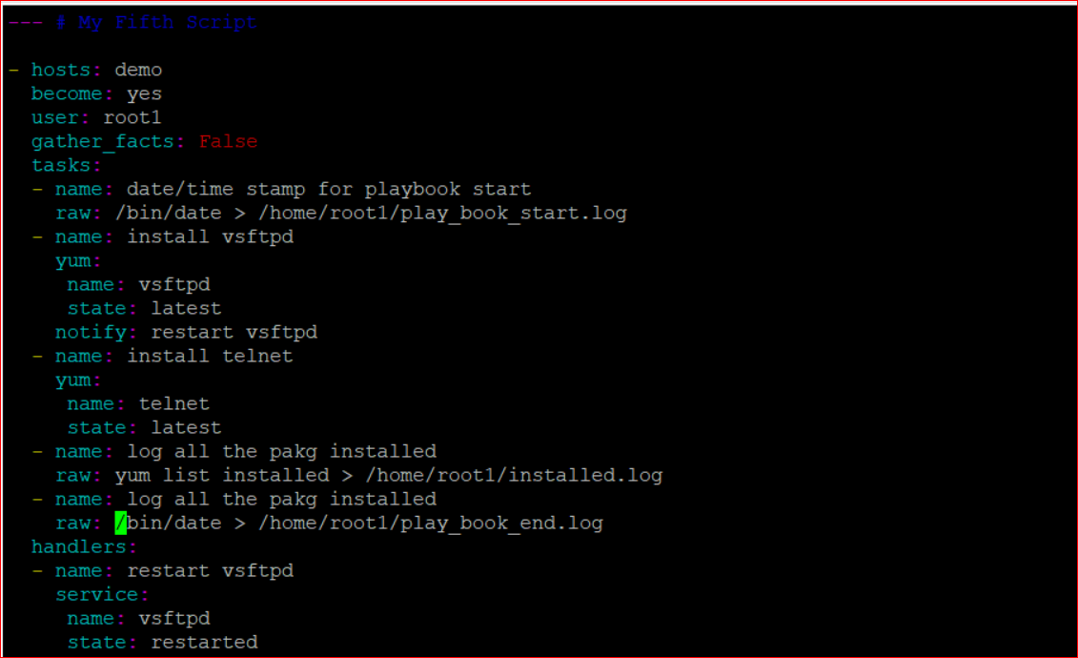

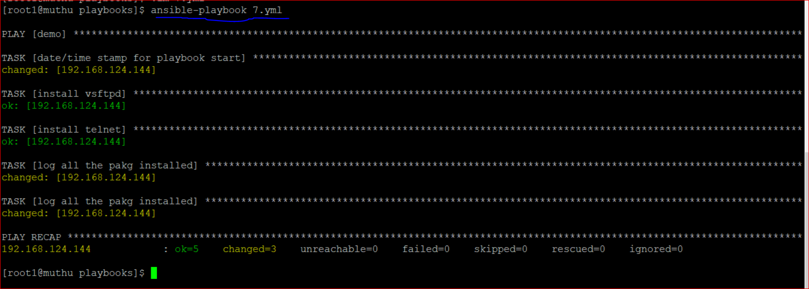

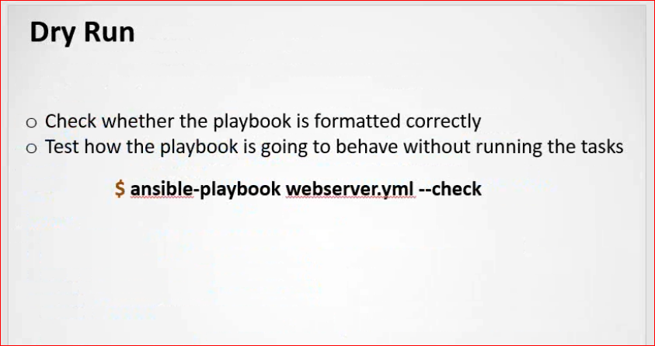

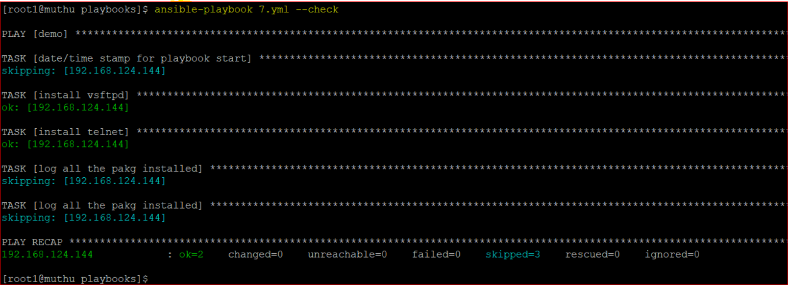

Async mode will run the Task parallelly

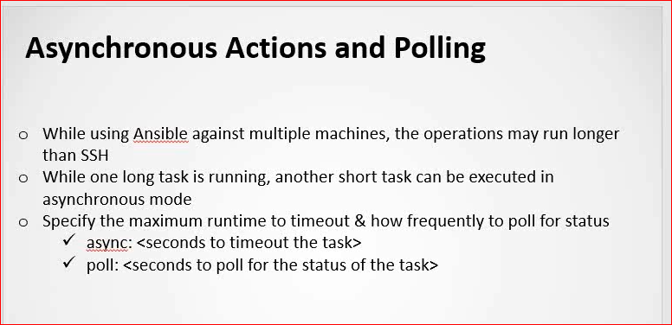

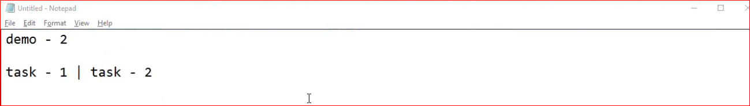

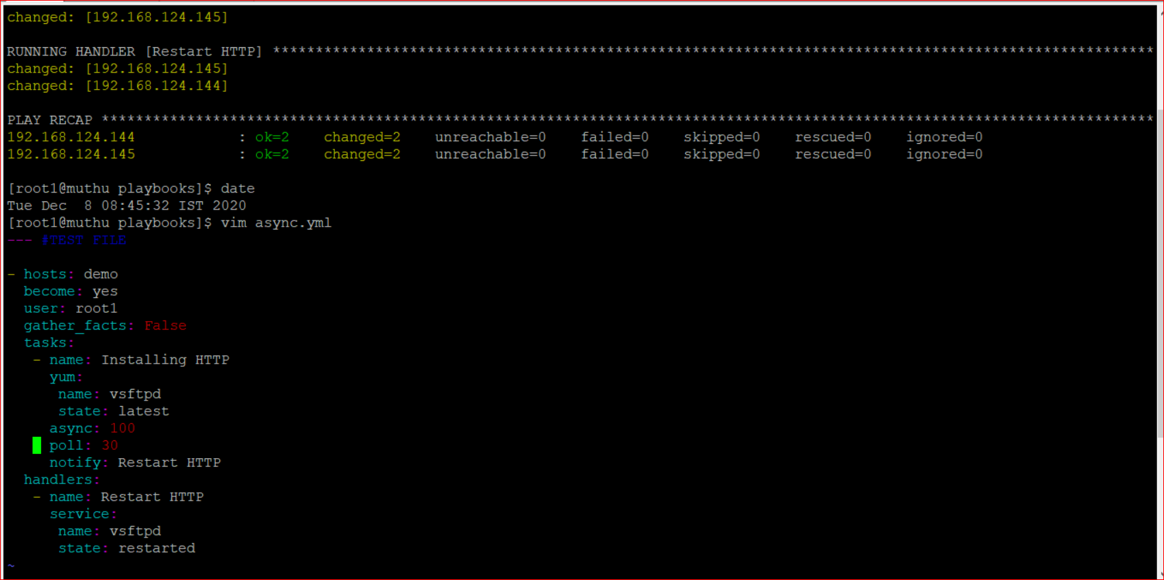

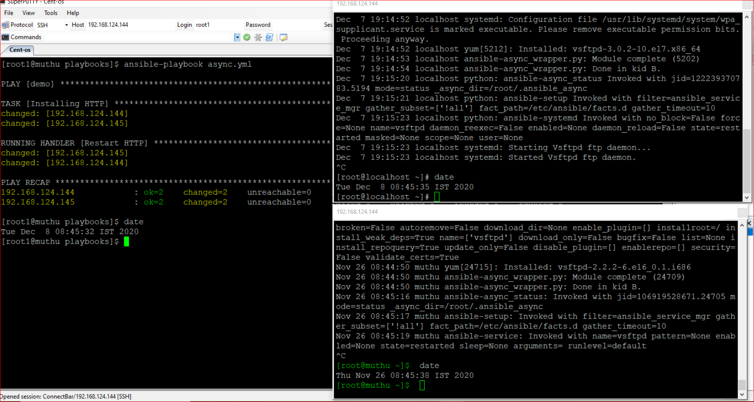

**Run Once:**

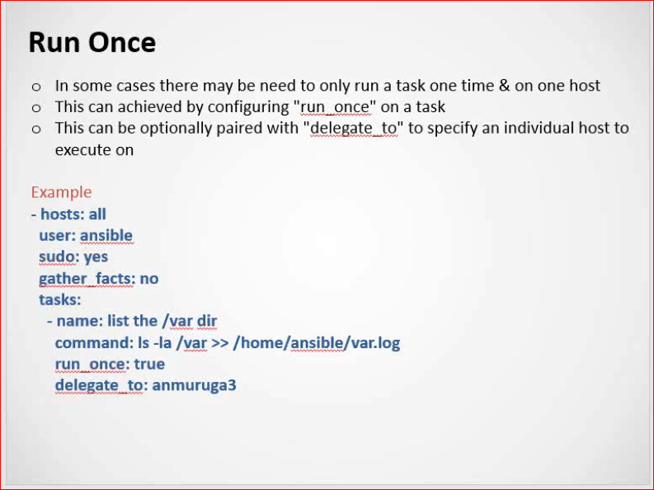

Example:

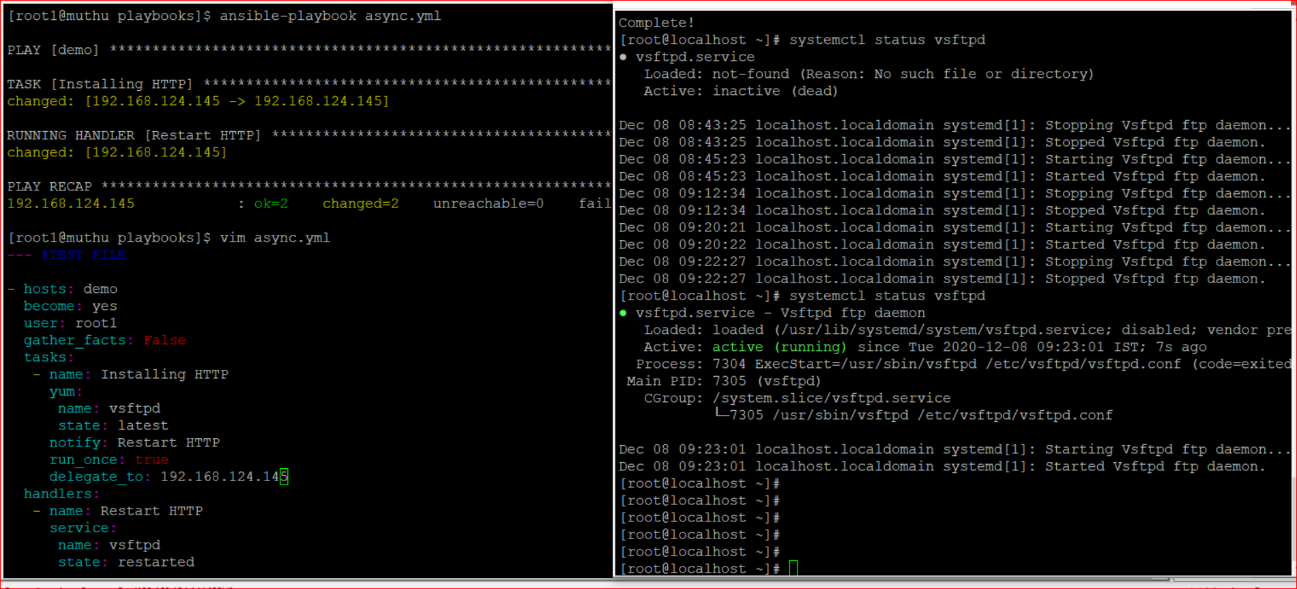

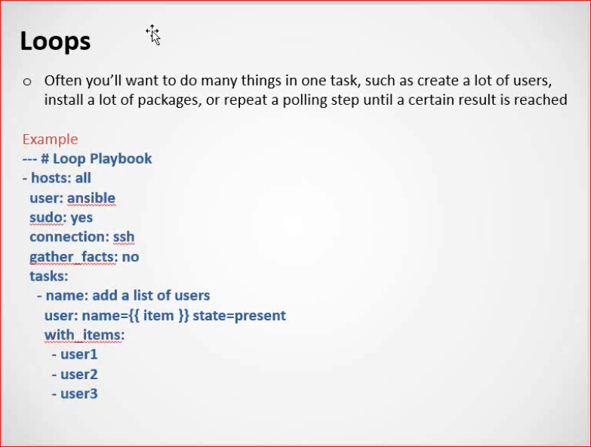

Example:

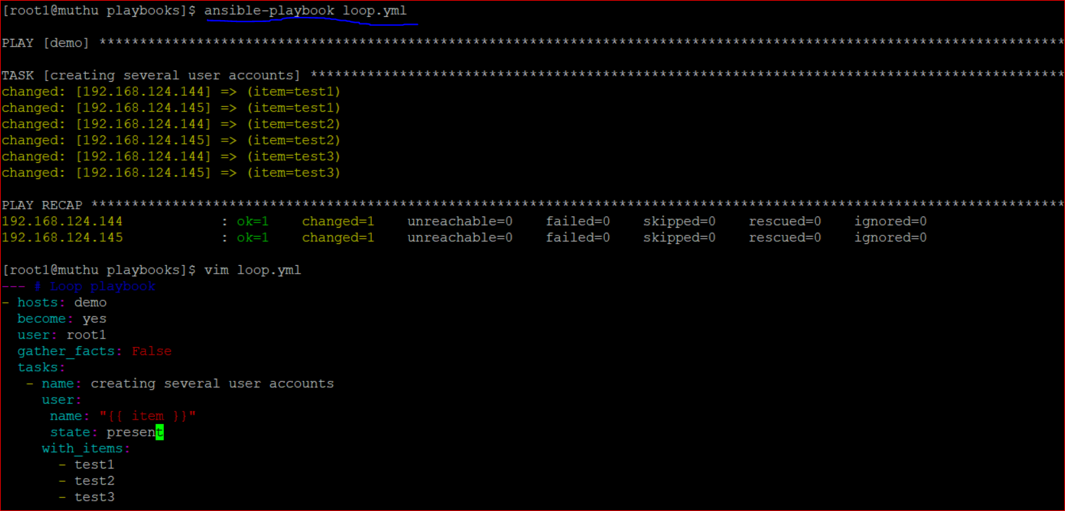



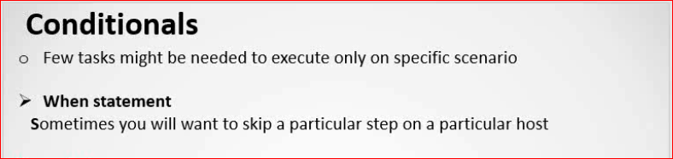

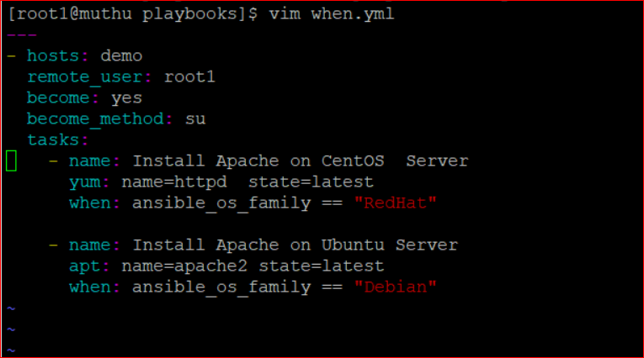

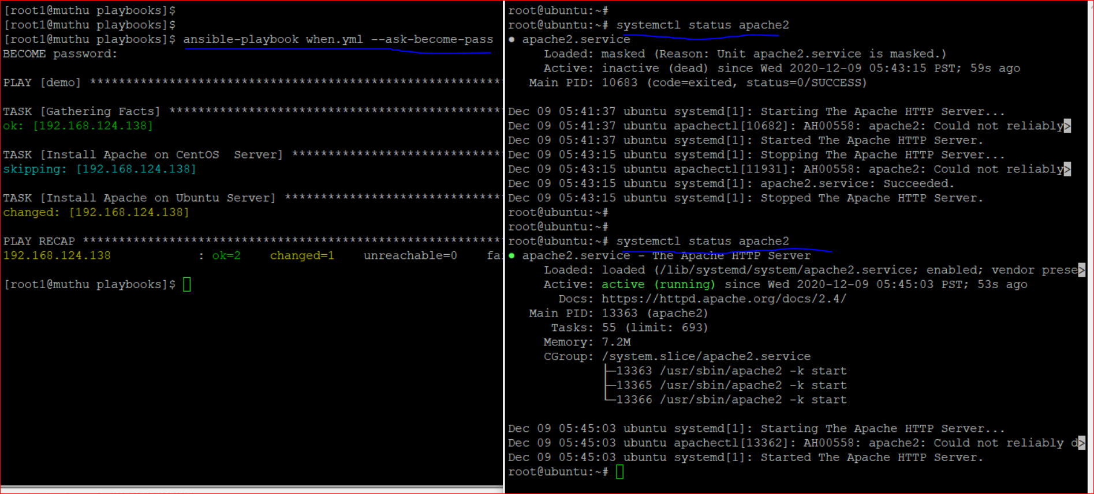



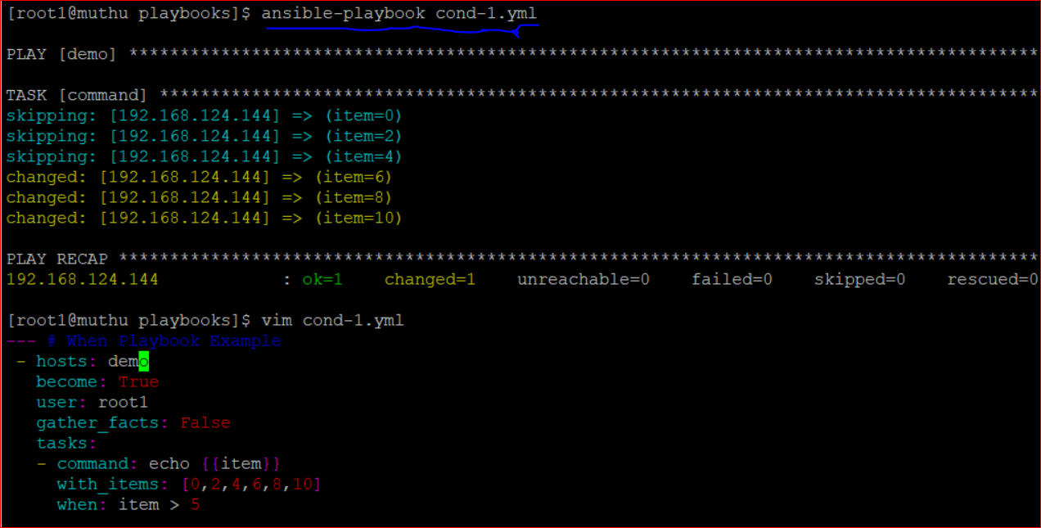

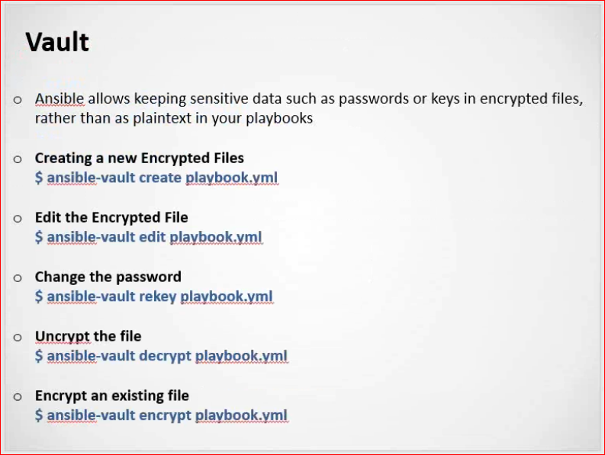

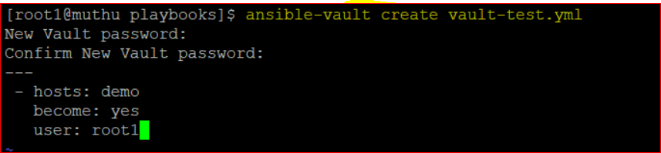

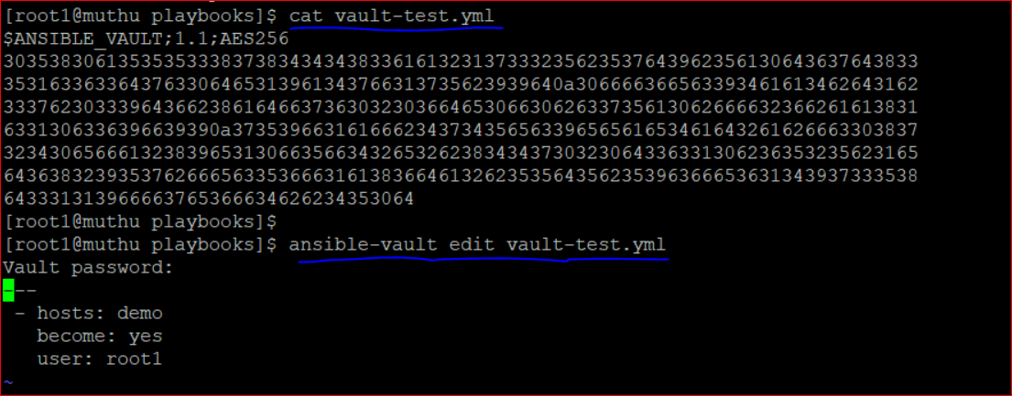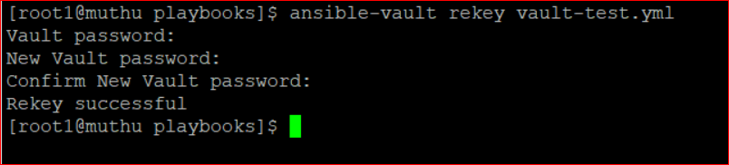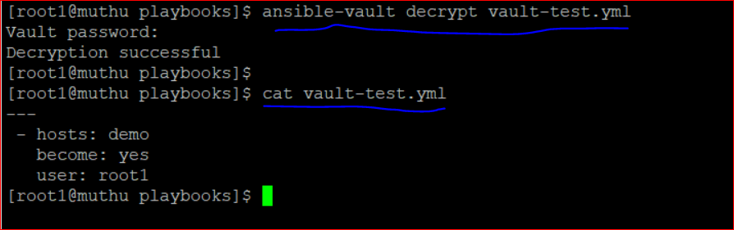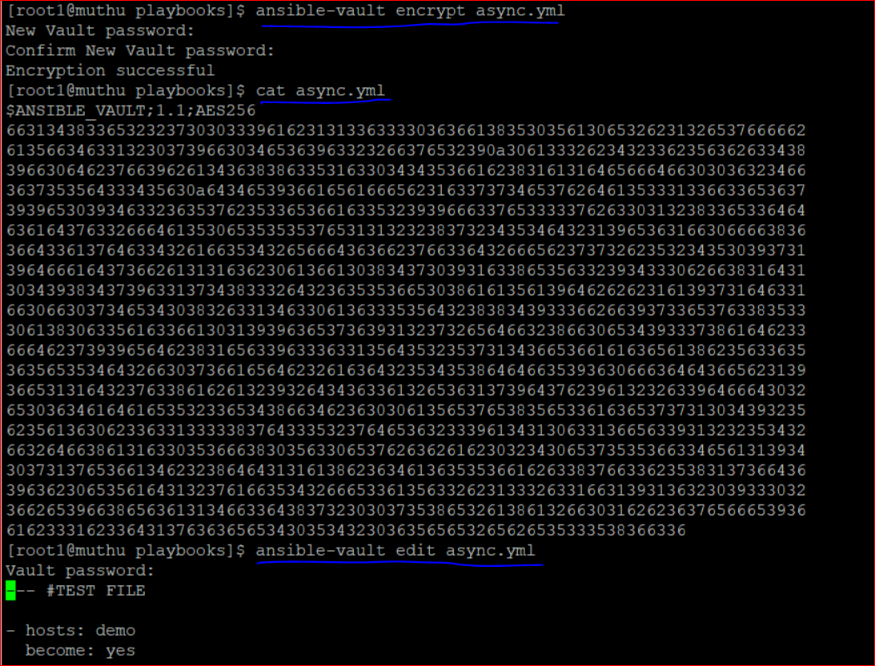

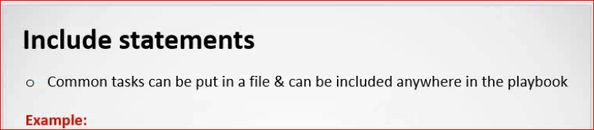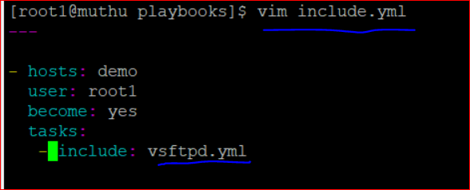

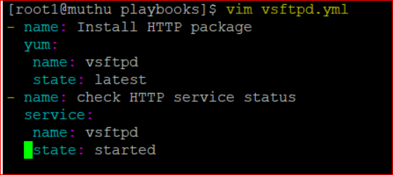

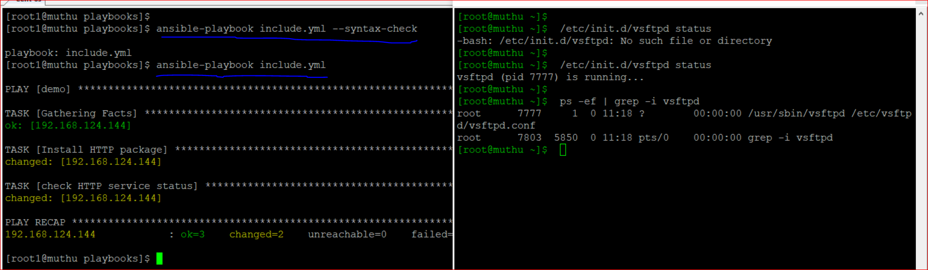

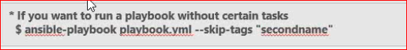

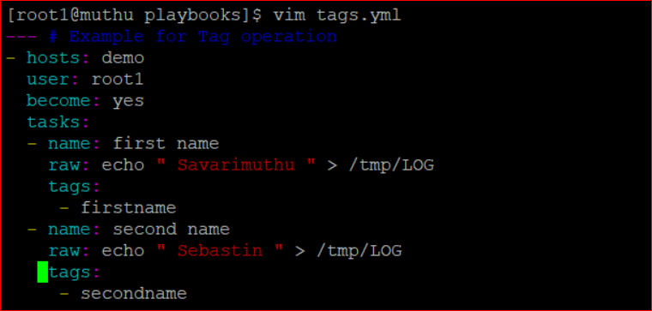

Output:

